Exercise 1: Problem Decomposition Practice
Break each of the following features into at least 5 small steps using pseudocode or
a numbered list. Work individually first, then share with a partner.
Feature 1: A user can reset their password by entering their email address.
- User enters email
- Display email input field
- User submits their email
2. Validate and verify email
- Check if email format is correct
- Check if email exists in the system
3. Generate and send reset link
- Create a secure reset token
- Send email with reset link
4. User resets password
- User clicks link and enters new password
- Validate password (match & strength)
5. Update password
- Save new password in database
- Invalidate token and confirm success
PSEUDOCODE CODE
START

INPUT email

IF email is invalid OR not found
SHOW error
ELSE
GENERATE reset_token
SEND reset link to email

IF user clicks link AND token is valid
INPUT new_password

IF password is valid
UPDATE password
SHOW success message
ELSE
SHOW error
ELSE
SHOW invalid/expired link

END

Feature 2: An admin can view a report of all transactions made in the last 7 days.
- Admin requests report
  - Admin navigates to reports page
  - Selects “Last 7 Days Transactions”
- Verify admin access
  - Check if user is logged in and has admin role
  - If not → deny access
- Determine date range
  - Get current date
  - Calculate date 7 days ago
- Fetch transactions
- Query database for transactions within the date range
- Store results
- Display report
  - Show transactions in a table/list
  - Optionally show totals (e.g., sum of transactions)

PSEUDOCODE CODE
START

IF user is not admin
SHOW access denied
ELSE
SET end_date = today
SET start_date = today - 7 days

FETCH transactions WHERE date BETWEEN start_date AND end_date

DISPLAY transactions

END

Feature 3: A rider requests a boda boda, and the nearest available driver is notified.
- Rider makes request
  - Rider enters pickup location
  - Submits ride request
- Validate request
  - Check if rider is logged in
  - Ensure location is provided
- Find nearest driver
  - Get rider’s location
  - Search for available drivers nearby
  - Select the closest one
- Notify driver
  - Send ride request notification to selected driver
  - Include pickup details
- Handle driver response
  - If driver accepts → confirm ride to rider
  - If driver rejects → find another driver

PSEUDOCODE CODE
START

INPUT rider_location

IF rider not logged in OR location missing
SHOW error
ELSE
FIND nearest available driver

IF driver found
SEND request to driver

IF driver accepts
CONFIRM ride
ELSE
FIND another driver
ELSE
SHOW "No drivers available"

END

Exercise 2: Code Quality Refactoring
(1) What does this code do?
This method:
- Takes in email (e), password (p), name (n), and phone (ph)
- Checks if:
  - Email is valid (contains "@")
  - Password length is greater than 5
  - Name and phone are not null
- If all conditions pass:
  - Prints user details
  - Simulates sending a welcome email
  - Simulates sending a welcome SMS

(2) Naming Problems
The naming here is… honestly rough
- class A → meaningless
- method x → unclear purpose
- Parameters:
  - e → should be email
  - p → should be password
  - n → should be name
  - ph → should be phoneNumber

(3) Does the function do ONE thing?
No — it violates the Single Responsibility Principle
It does multiple things:
- Validation
- Printing user details
- Sending email
- Sending SMS

(4) Repeated Patterns
Yes:
- "Sending welcome..." appears multiple times → similar behaviour
- Output logic is mixed together → should be separated
Also:
- No reusable methods (everything is hardcoded inside one block)

public class UserService {

public void registerUser(String email, String password, String name, String phoneNumber) {
if (!isValidUser(email, password, name, phoneNumber)) {
System.out.println("Invalid user data.");
return;
}

printUserDetails(name, email);
sendWelcomeEmail(email);
sendWelcomeSMS(phoneNumber);
}

private boolean isValidUser(String email, String password, String name, String phoneNumber) {
return email != null && email.contains("@") &&
password != null && password.length() > 5 &&
name != null &&
phoneNumber != null;
}

private void printUserDetails(String name, String email) {
System.out.println("User: " + name);
System.out.println("Email: " + email);
}

private void sendWelcomeEmail(String email) {
System.out.println("Sending welcome email to " + email);
}

private void sendWelcomeSMS(String phoneNumber) {
System.out.println("Sending welcome SMS to " + phoneNumber);
}
}

Exercise 3: Your First Git Workflow (Hands-On) Complete this exercise in your terminal. Take a screenshot of your terminal after each major step
Part A – Create a Repository
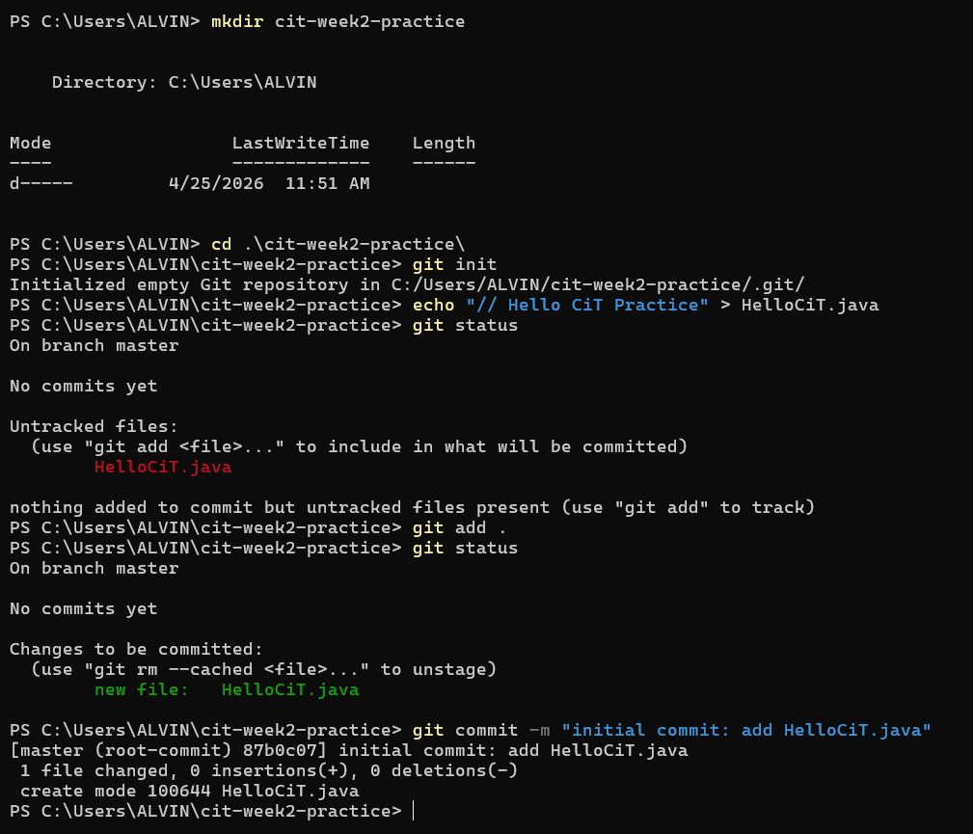

Part B - Branching
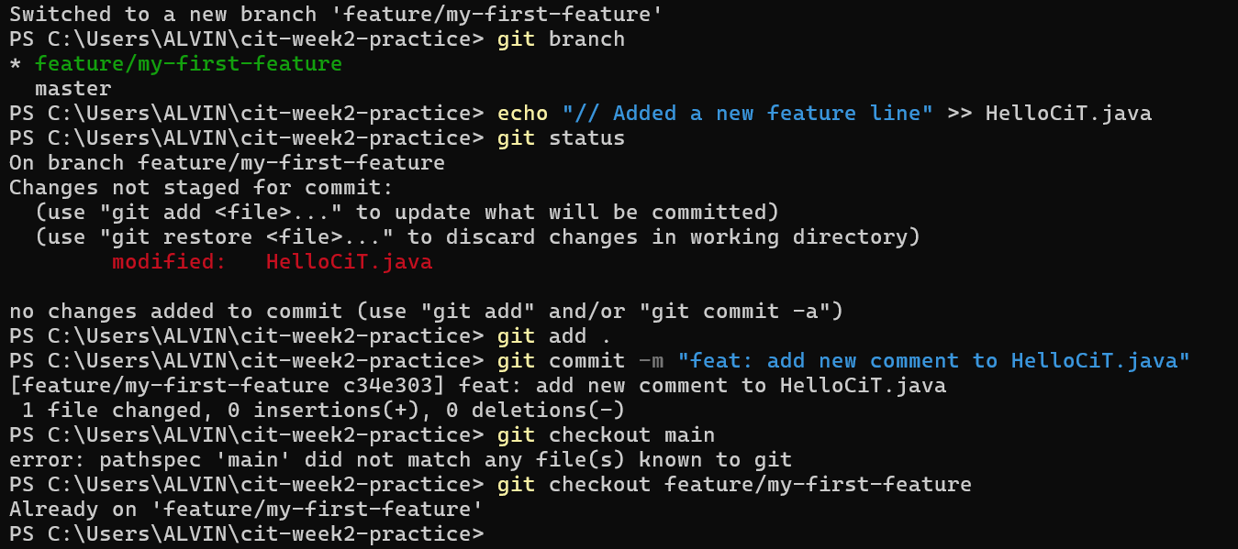

Part C – GitHub
https://github.com/Alvin11David/Church-In-Technology

"How to Write a Git Commit Message" by Chris Beams

- Separate subject from body with a blank line.
- Limit the subject line to 50 characters.
- Capitalize the subject line.
- Do not end the subject line with a period.
- Use the imperative mood in the subject line.
- Wrap the body at 72 characters.
- Use the body to explain what and why vs. how.

